**CLASSIC LOAD BALANCER**

* STEP 1 OPEN EC2 AND CLICK LOAD BALANCER AND CLICK CREATE LOAD BALANCER.

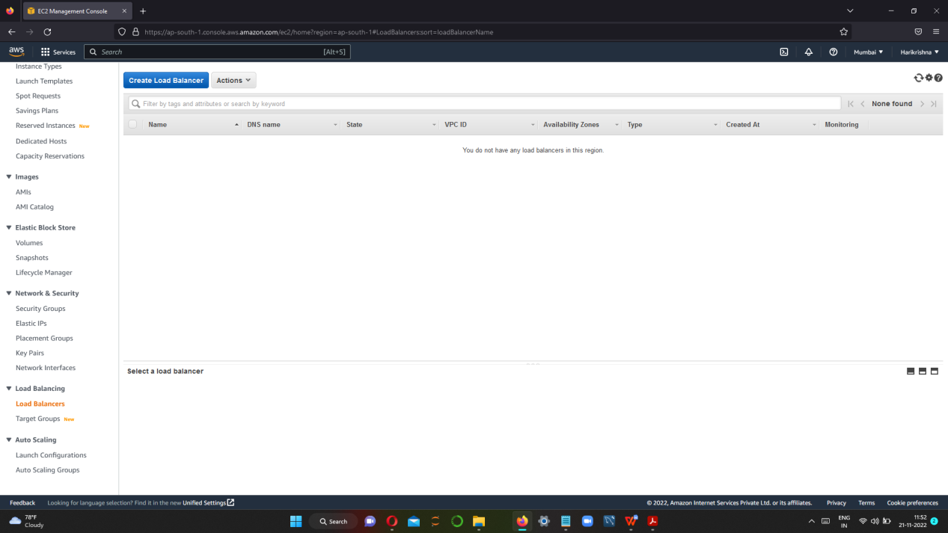

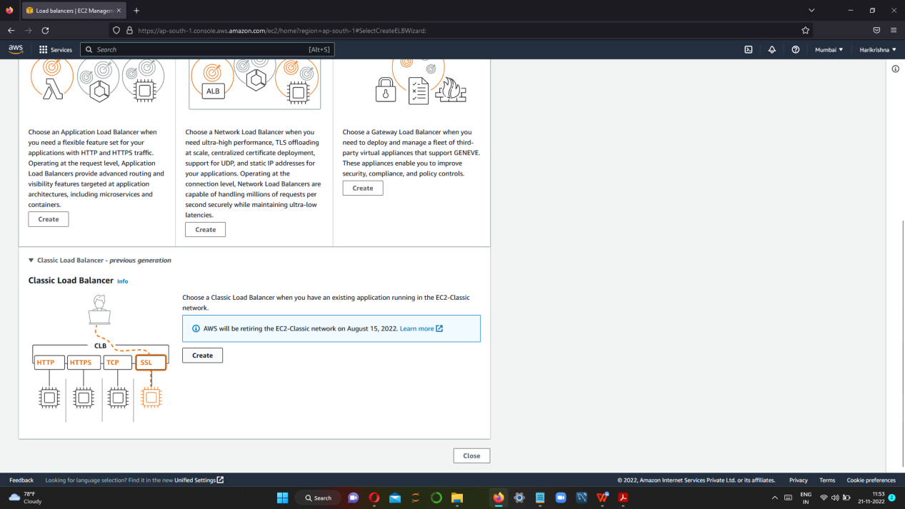

* STEP 2 I) NAME THE LOAD BALANCER AND KEEP THE VPC AS DEFAULT AS IT IS.

II) KEEP PROTOCOL AS HTTP.

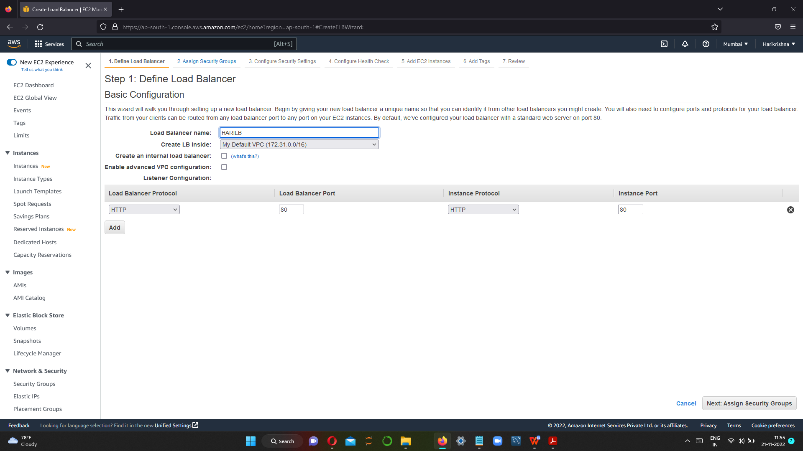

* STEP 3 CREATE NEW SECURITY GROUP AND KEEP TYPE AS ALL TCP.

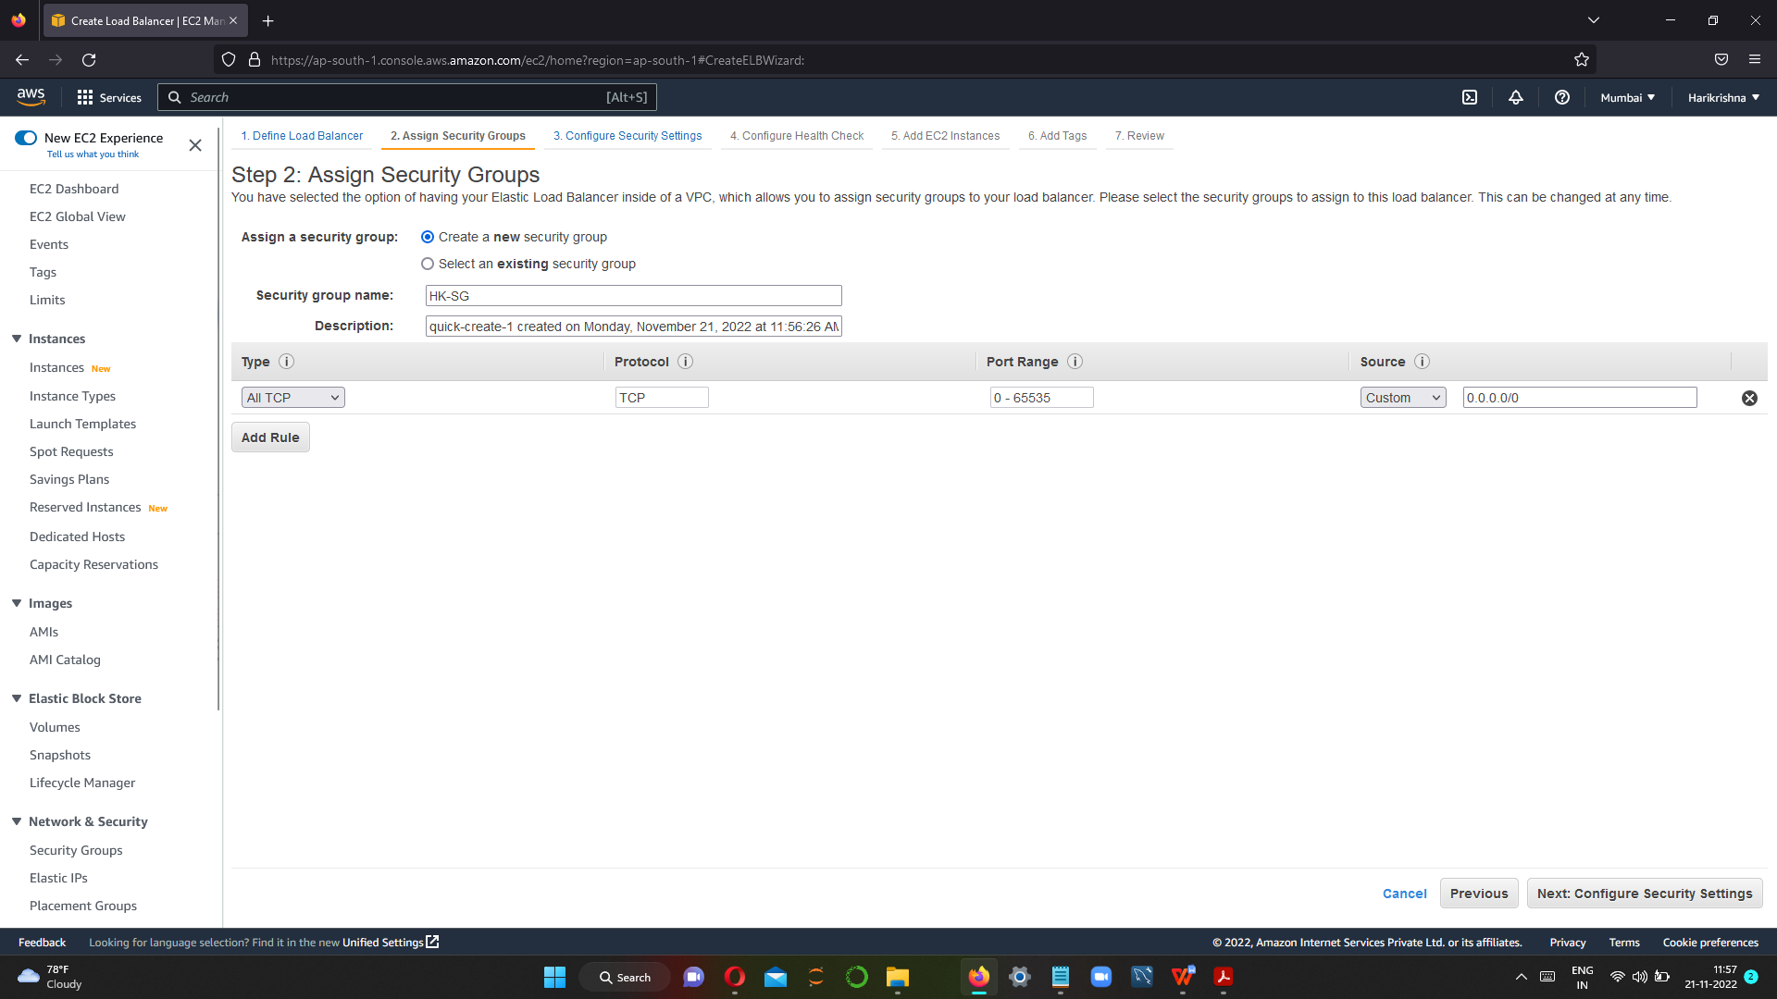

* STEP 4 WE HAVE TO SET CONFIGURATION ON NEEDS OF THE LOAD BALANCER TO HEALTH CHECK OF THE SERVER AND SET TIME,INTERVAL IN WHICH OUR CLASSIC LOAD BALANCER WILL GO AND HIT THE SERVER.

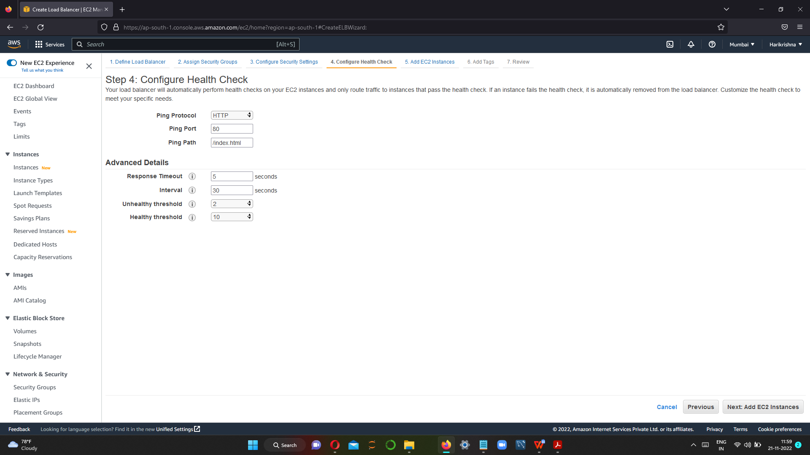

* STEP 5:REVIEW AND CREATE THE LOAD BALANCER.

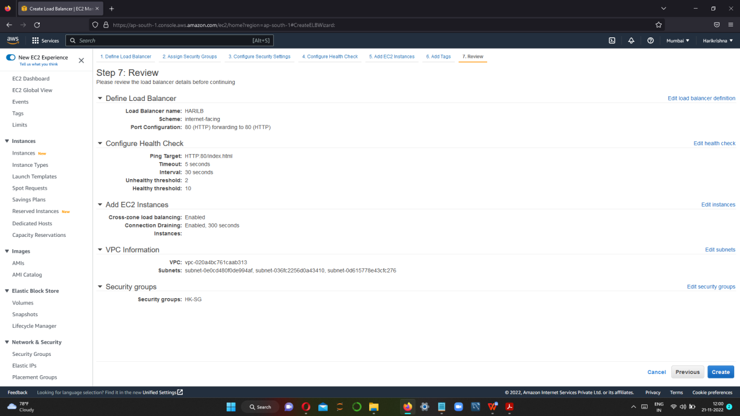

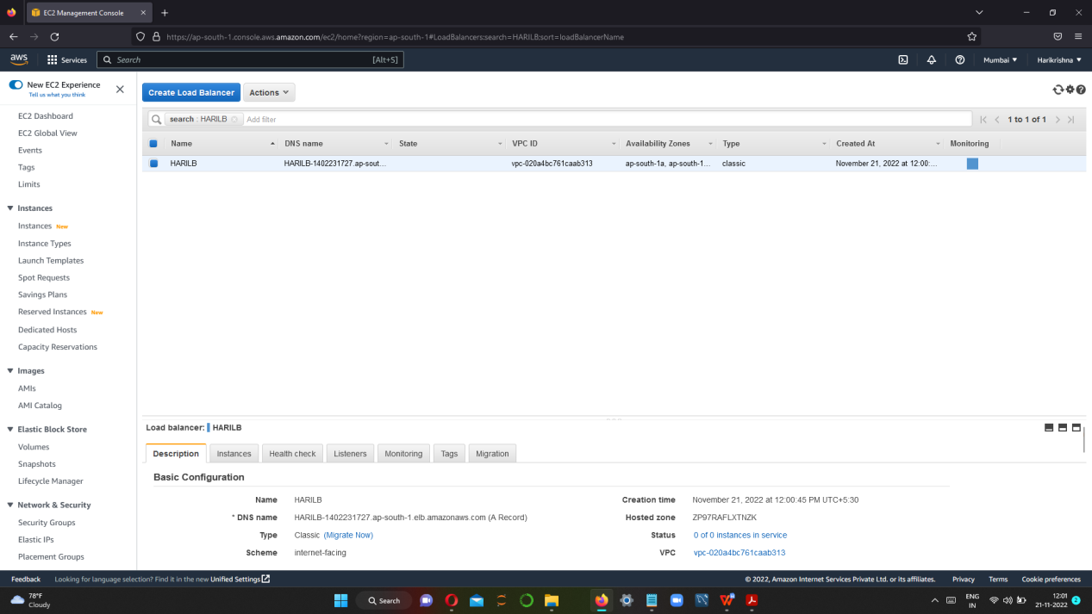

STEP 6 GO TO EC2 INSTANCE IN NEW TAB AND COPY OF AMI ID FREE TIER.

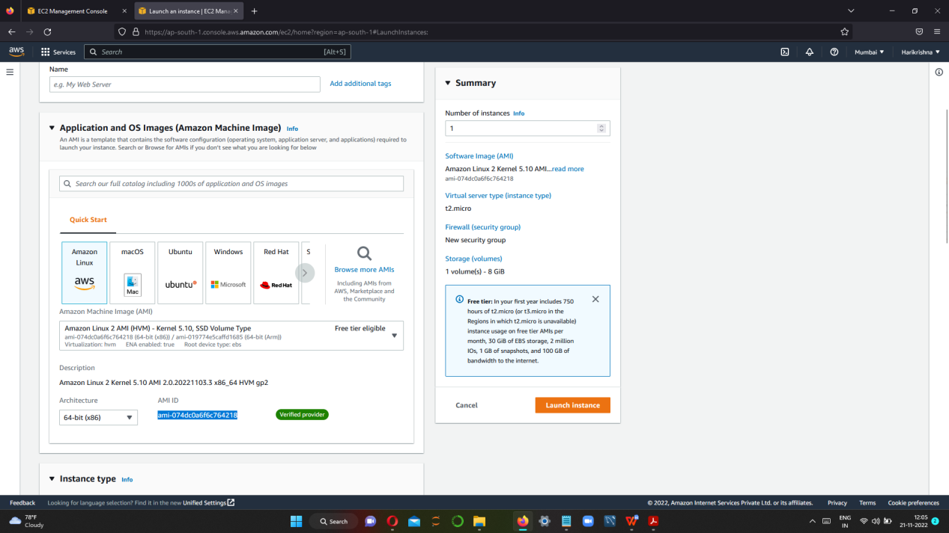

STEP 7 ONCE COPYING THE AMI ID , GO TO LAUNCH CONFIGURATION AND CLICK CREATE LAUNCH CONFIGURATION.

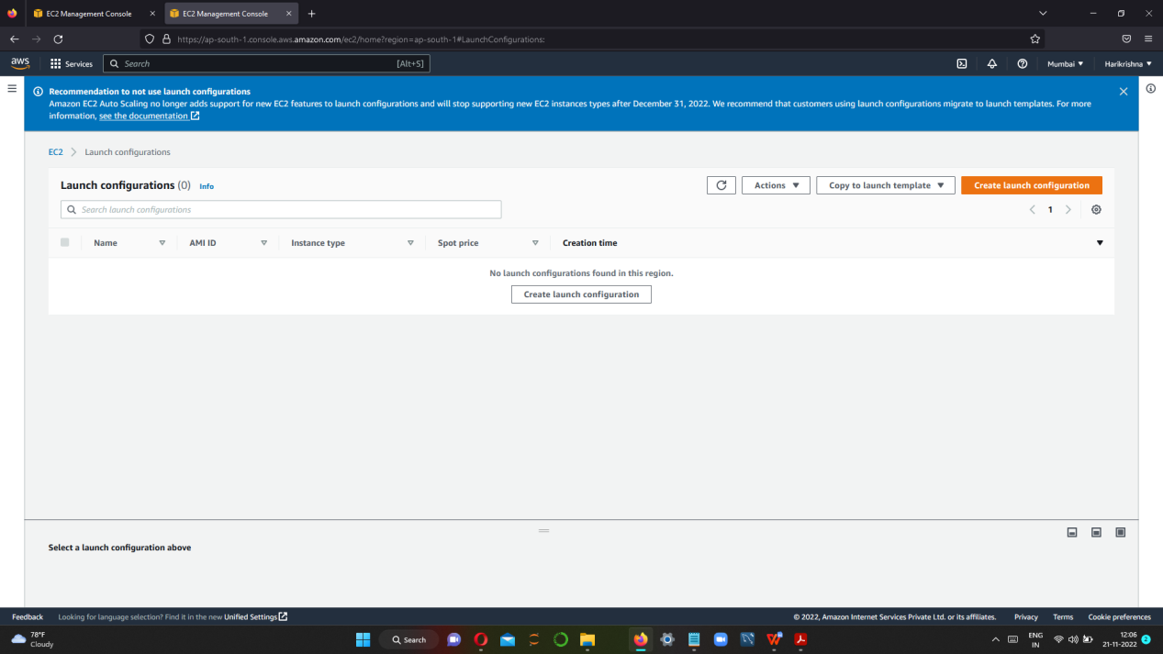

CLICK CREATE LAUNCH CONFIGURATION.

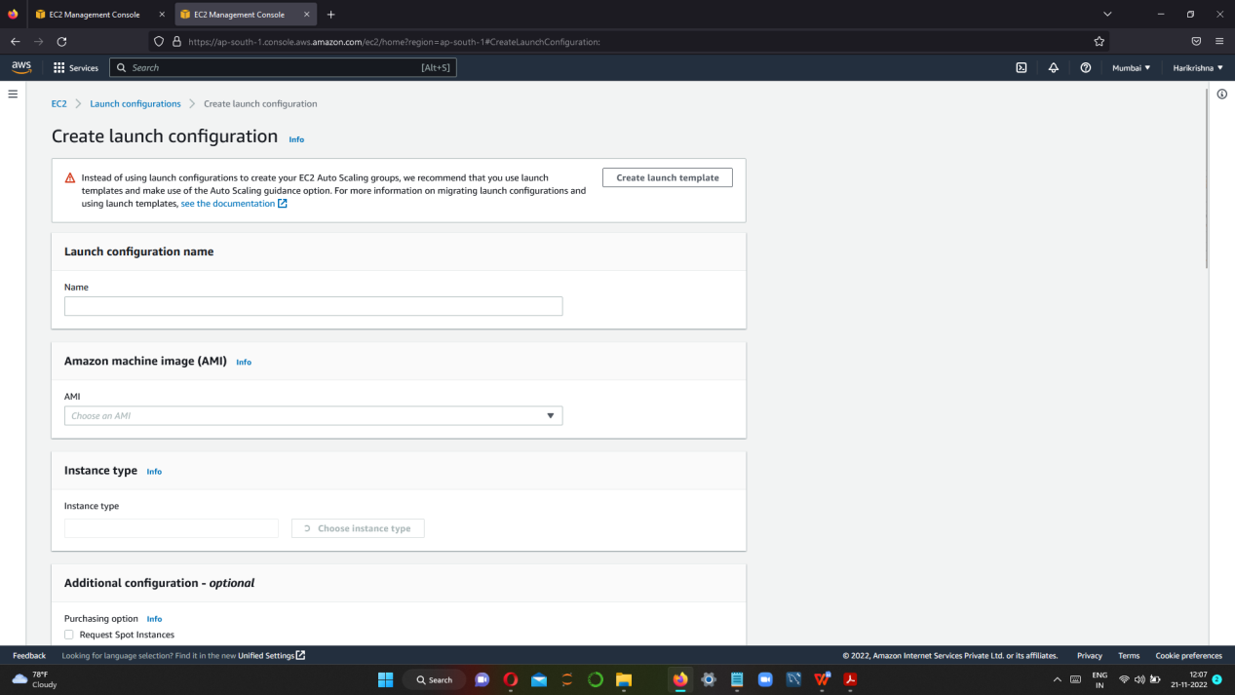

STEP 8 GIVE LAUNCH CONFIGURATION NAME ,PASTE AMI ID ---> SELECT INSTANCE TYPE

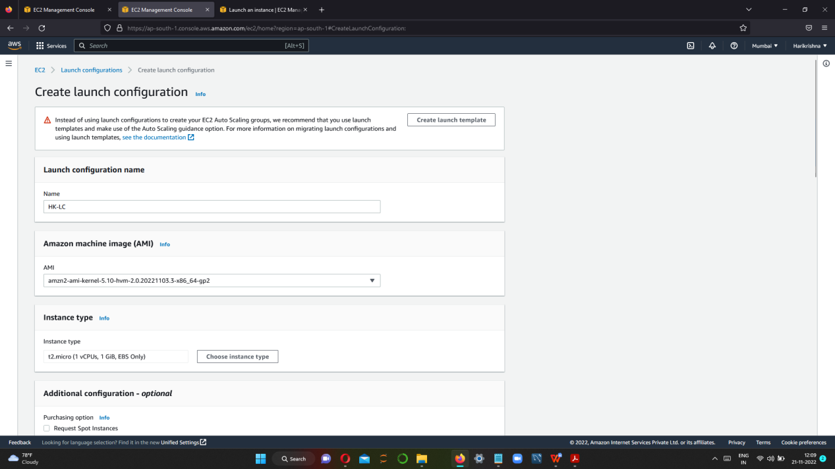

STEP 9 GO TO ADDITIONAL CONFIGURATION AND TYPE SIMPLE SCRIPT IN USER DATA.

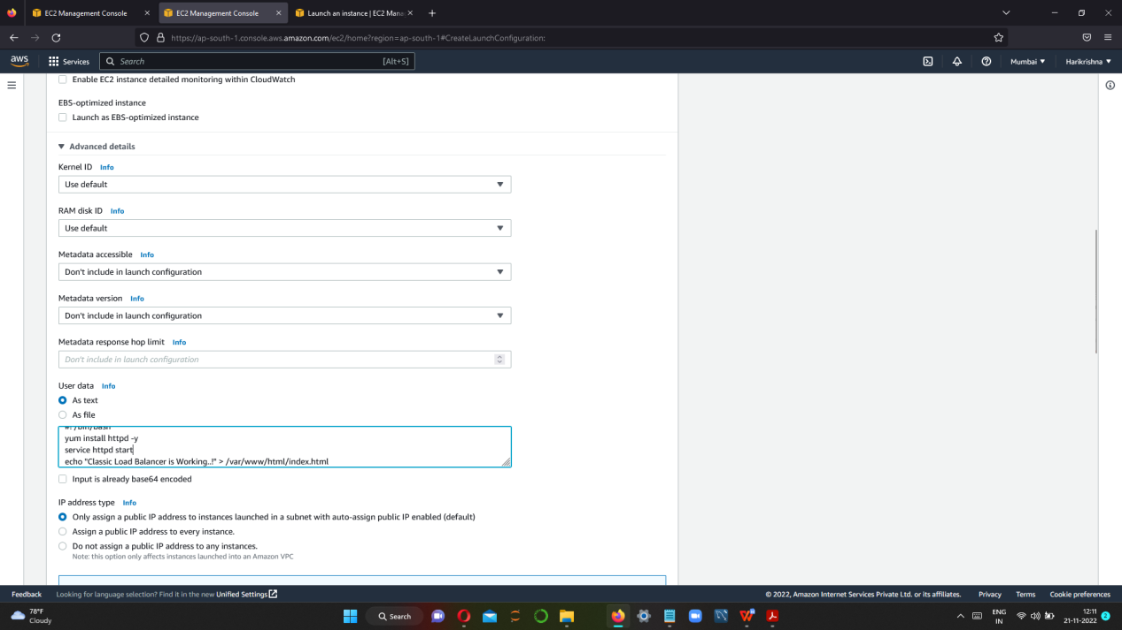

STEP 10 SELECT THE SECURITY GROUP AND SELECT THE SECURITY GROUP WHICH WE CREATED EARLIER

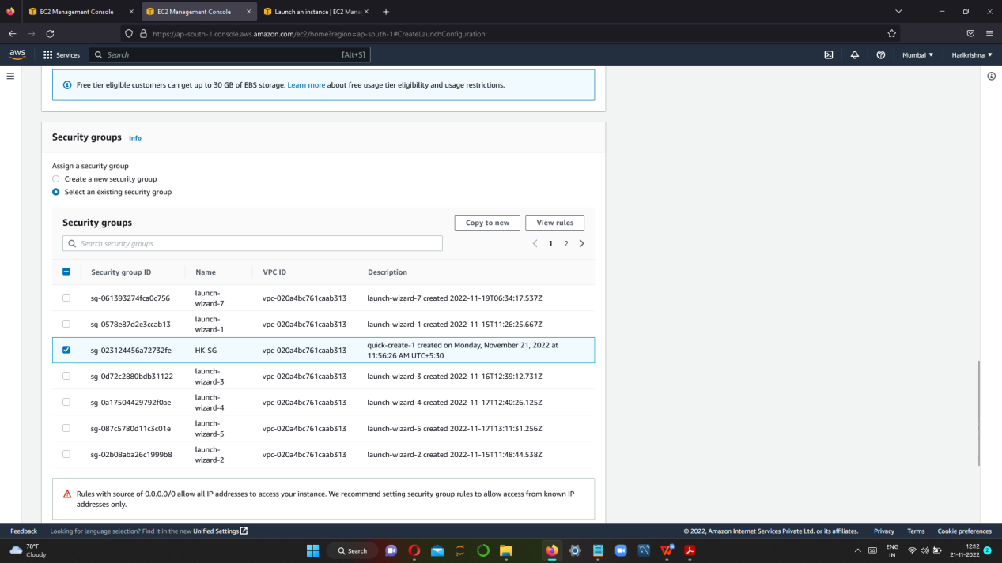

STEP 11 THEN SELECT THE EXISTING KEYPAIR AND CLICK CREATE LAUNCH CONFIGURATION.

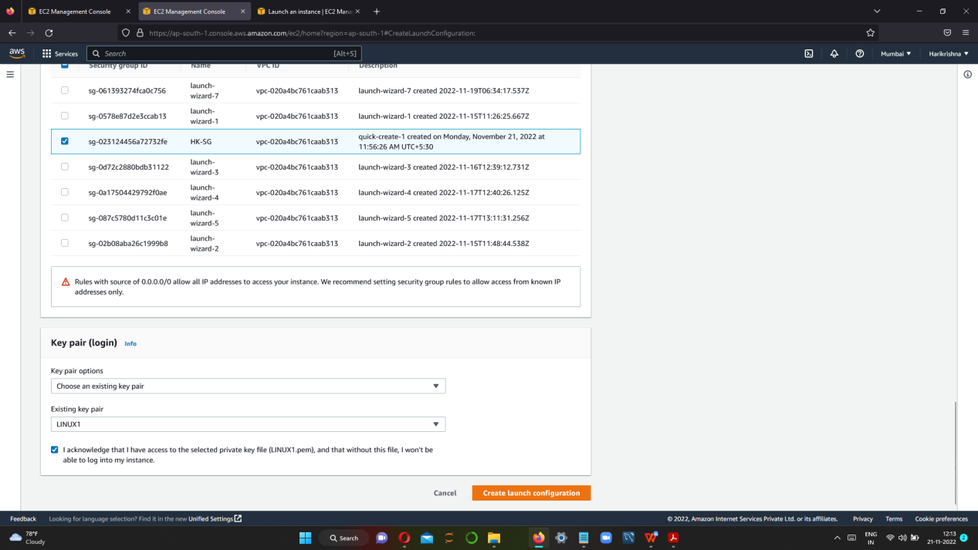

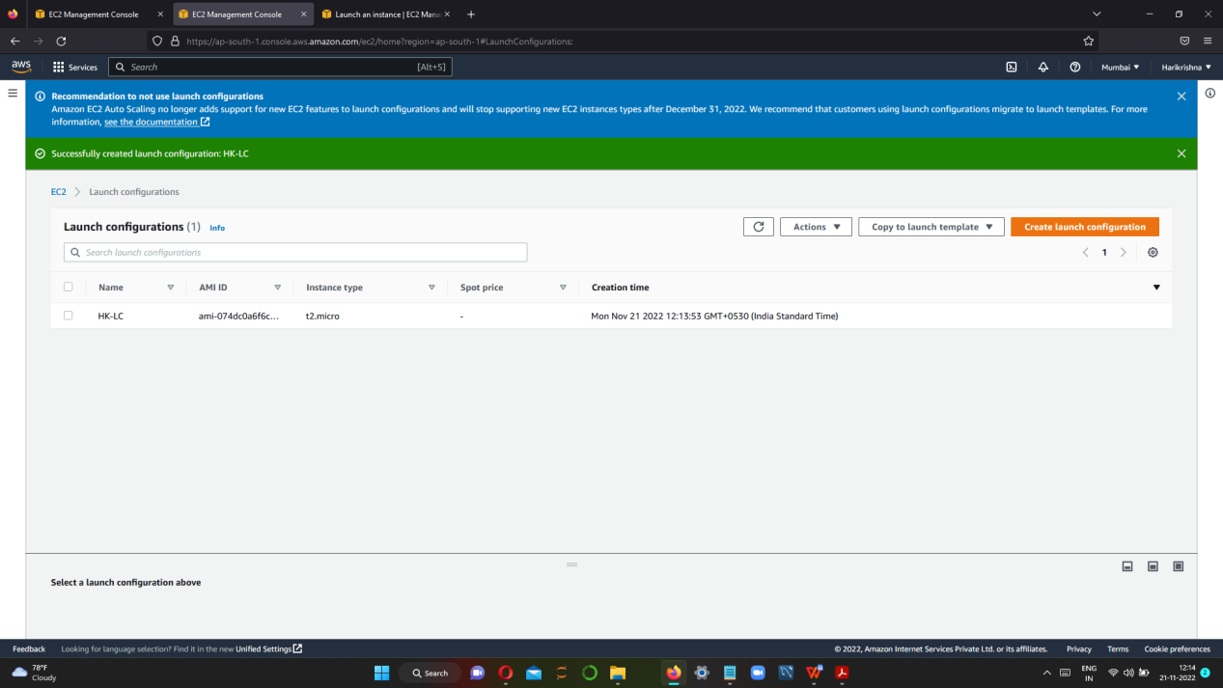

AUTO SCALING CREATION AND CONFIGURATION

STEP 1 GO TO AUTO SCALING GROUP AND CLICK CREATE AUTO SCALING GROUP

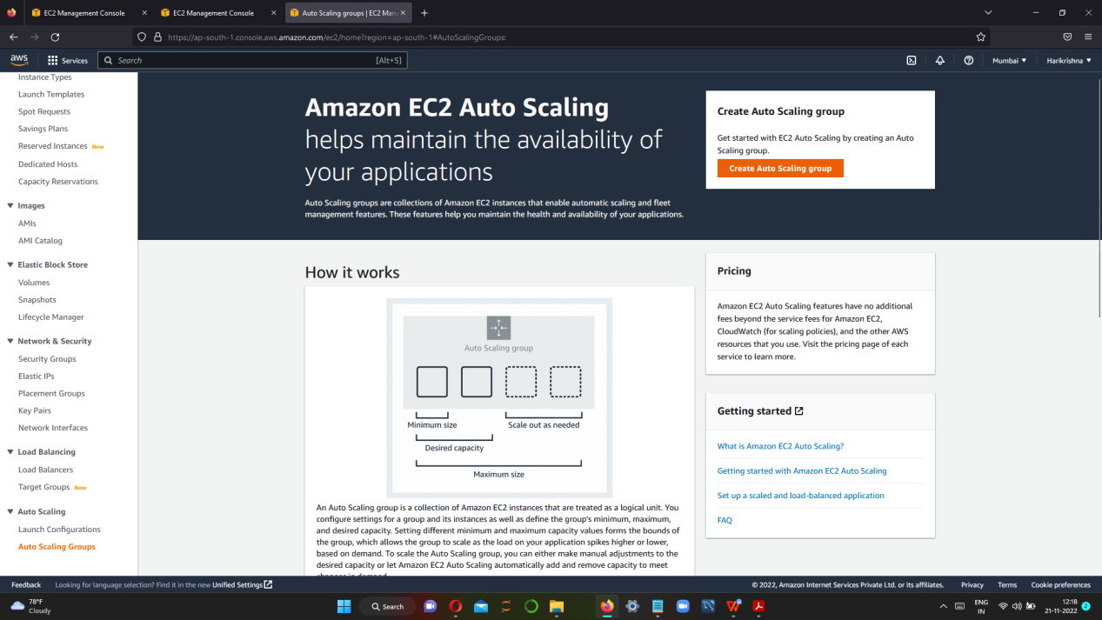

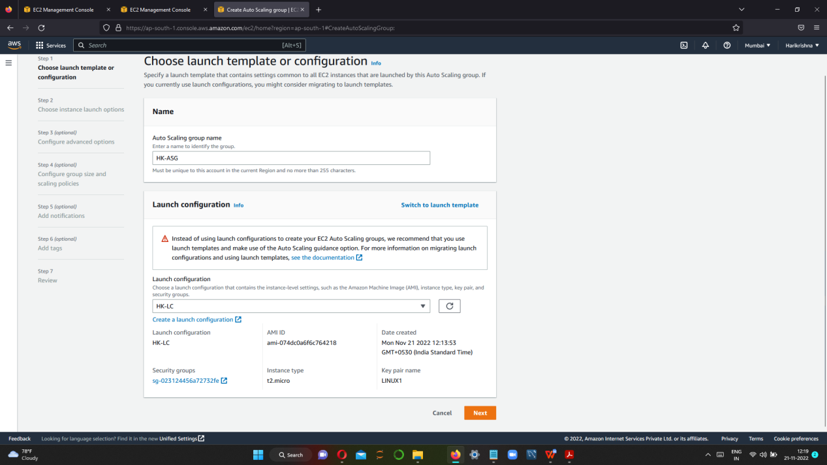

STEP 2 SELECT DEFAULT VPC AND SELECT ALL AVAILABLE SUBNETS

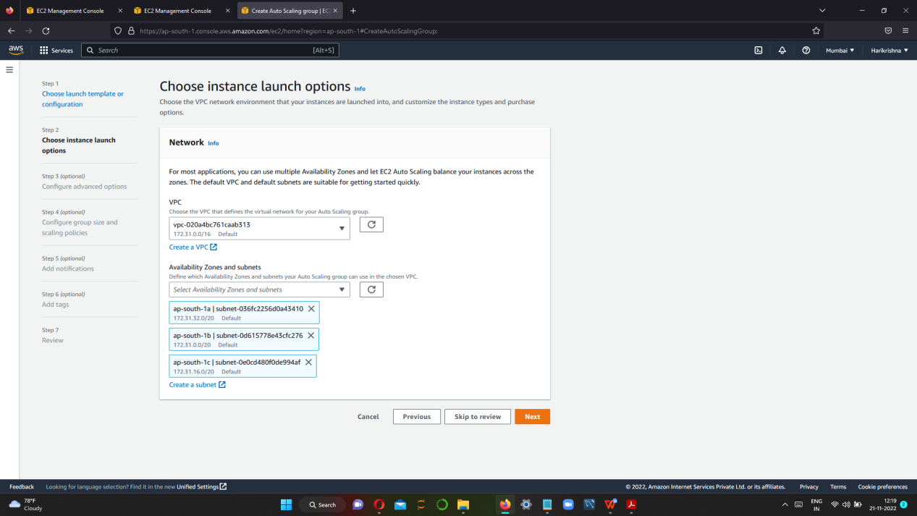

STEP 3 SELECT EXISTING LOAD BALANCER-->CHOOSE FROM CLASSIC LOAD BALANCER

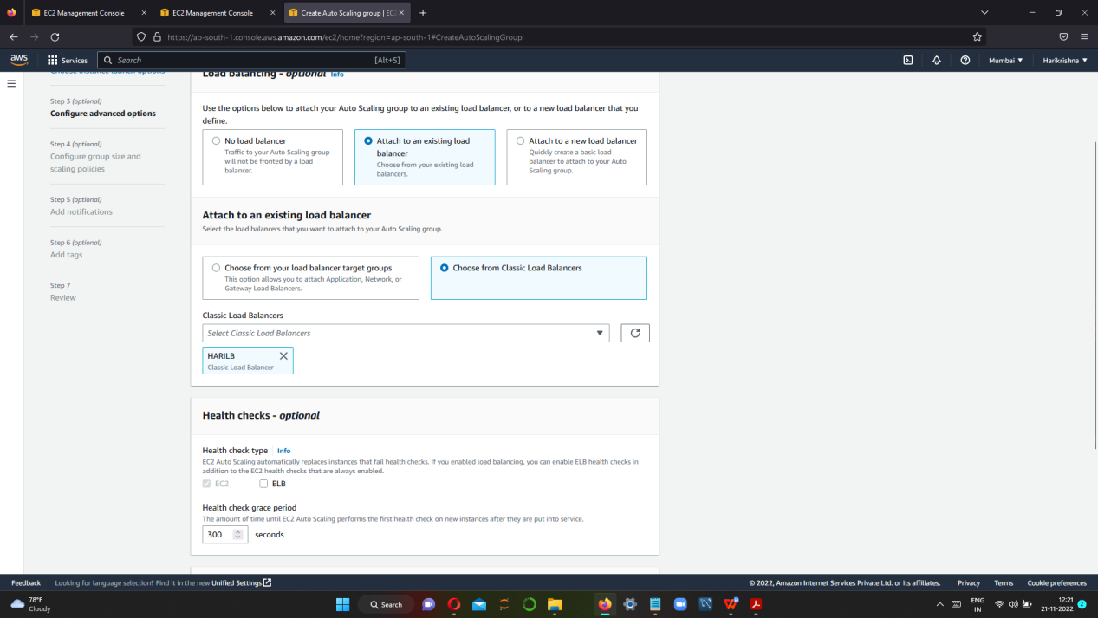

STEP 4 CONFIGURE GROUP SIZE AND SCALING POLICIES.

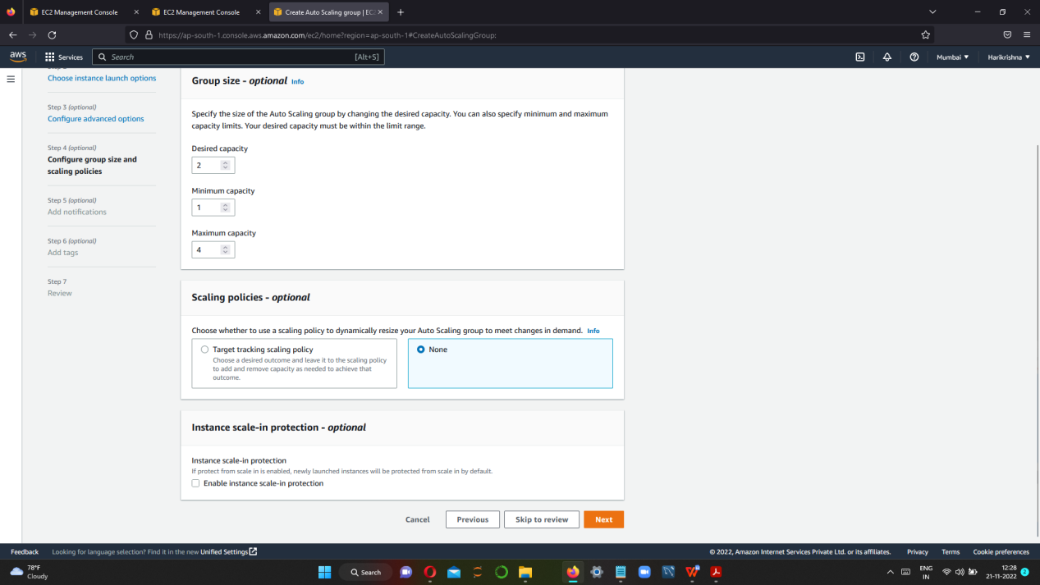

STEP 5 REVIEW AND CREATE

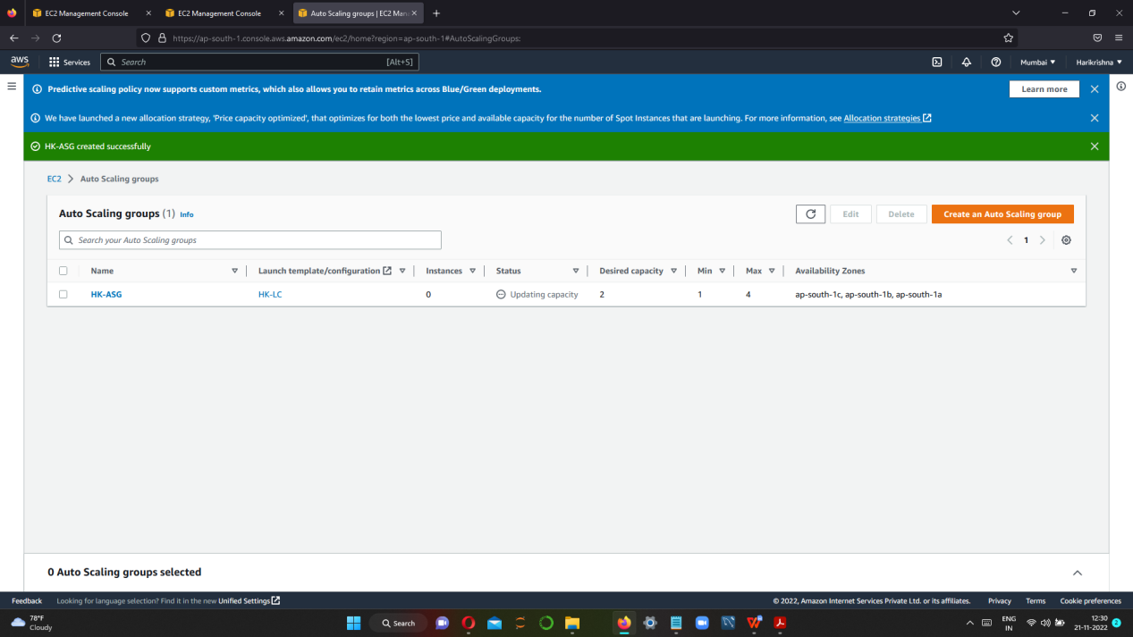

STEP 6 FINALLY TWO INSTANCE IS CREATED

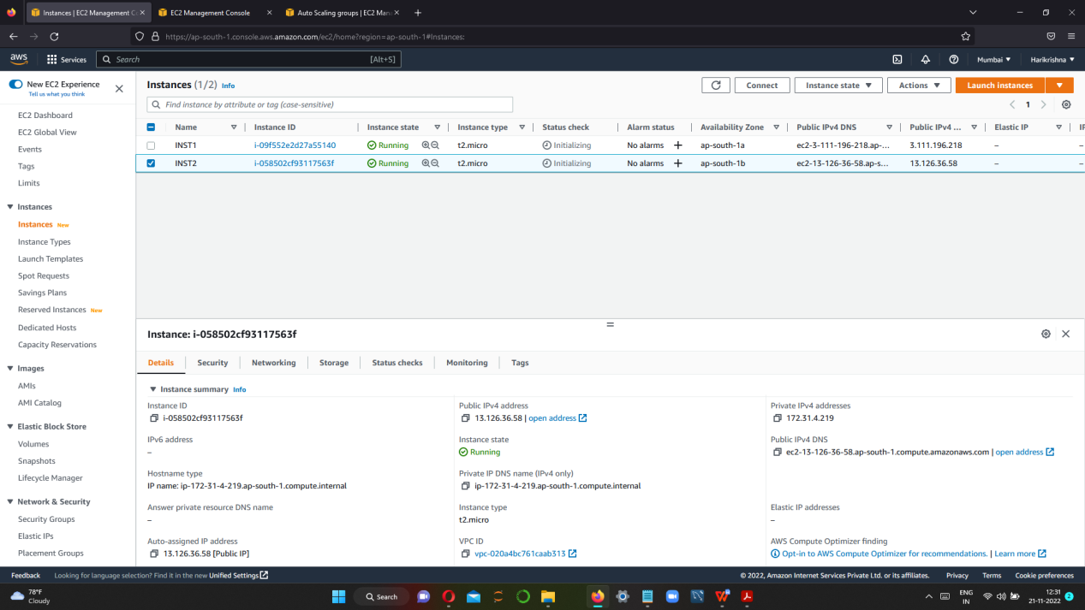

STEP 7 CHECK THE LOAD BALANCER IS IN SERVICE OR NOT.

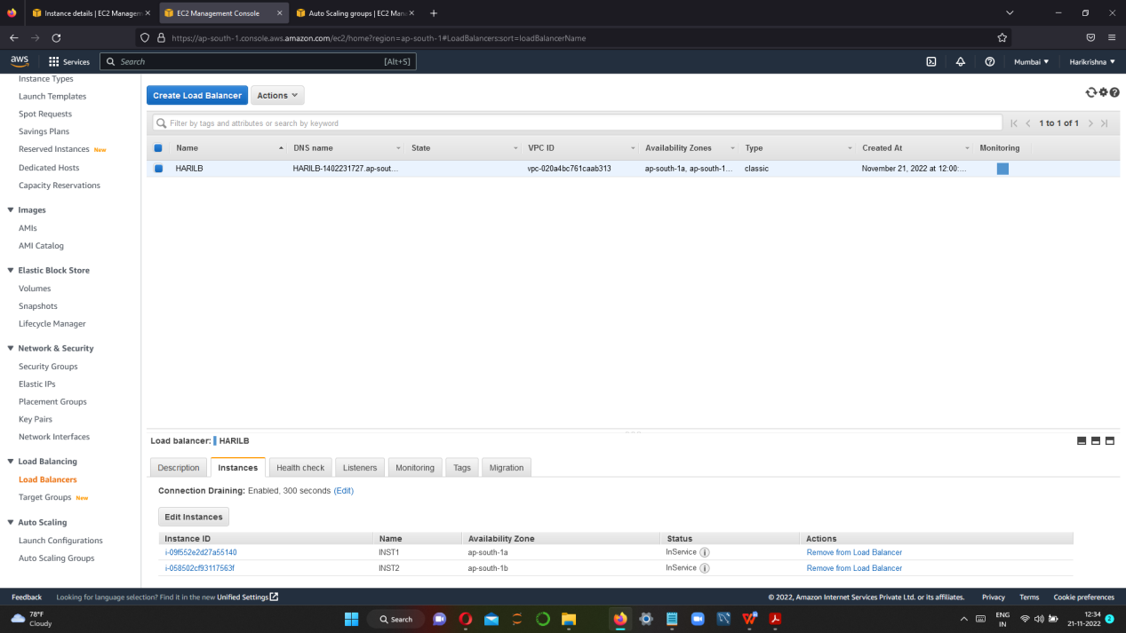

STEP 8 Click description and copy the DNS and hit in browser and check for the application.

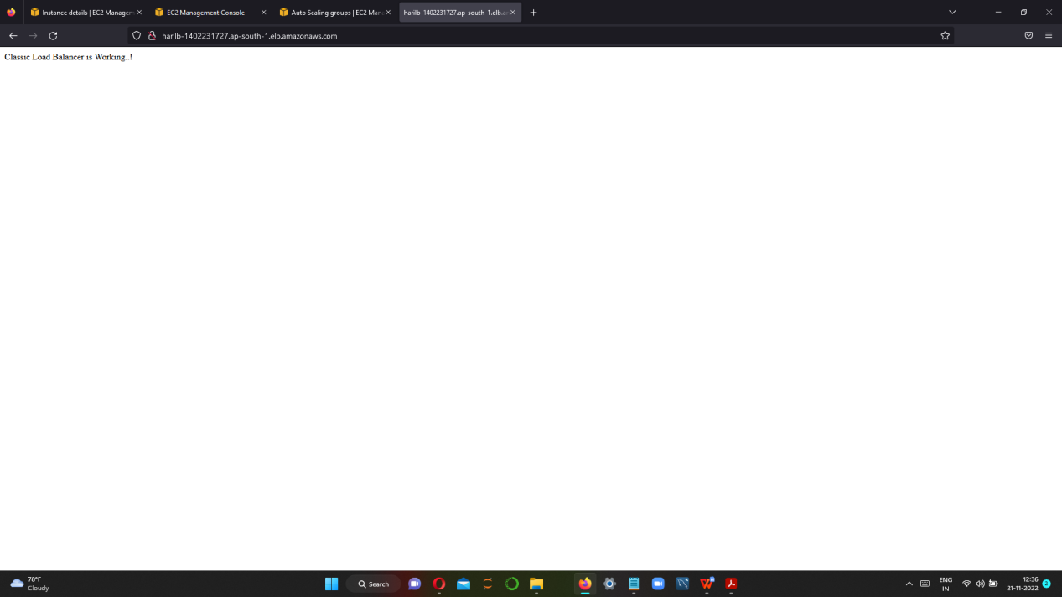

STEP 9 Now we should check with the 2 VMs by using their Public Ip and hitting it in browser.

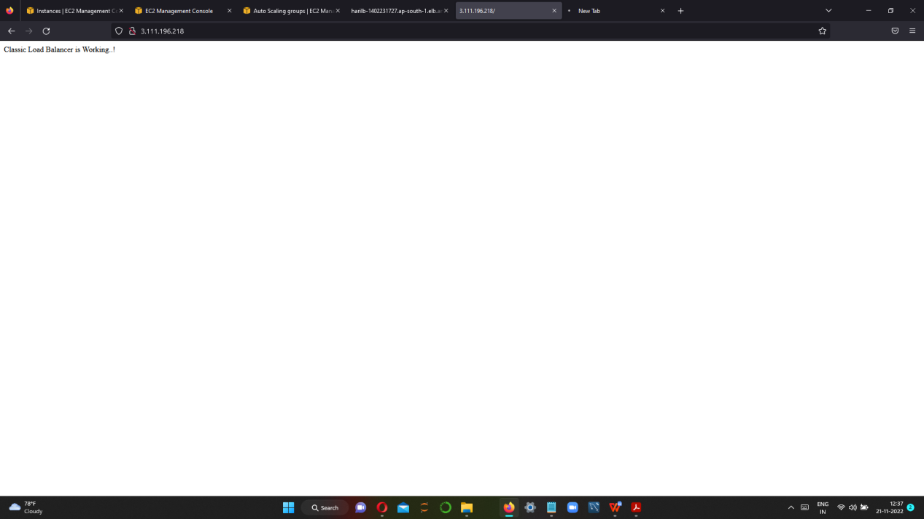

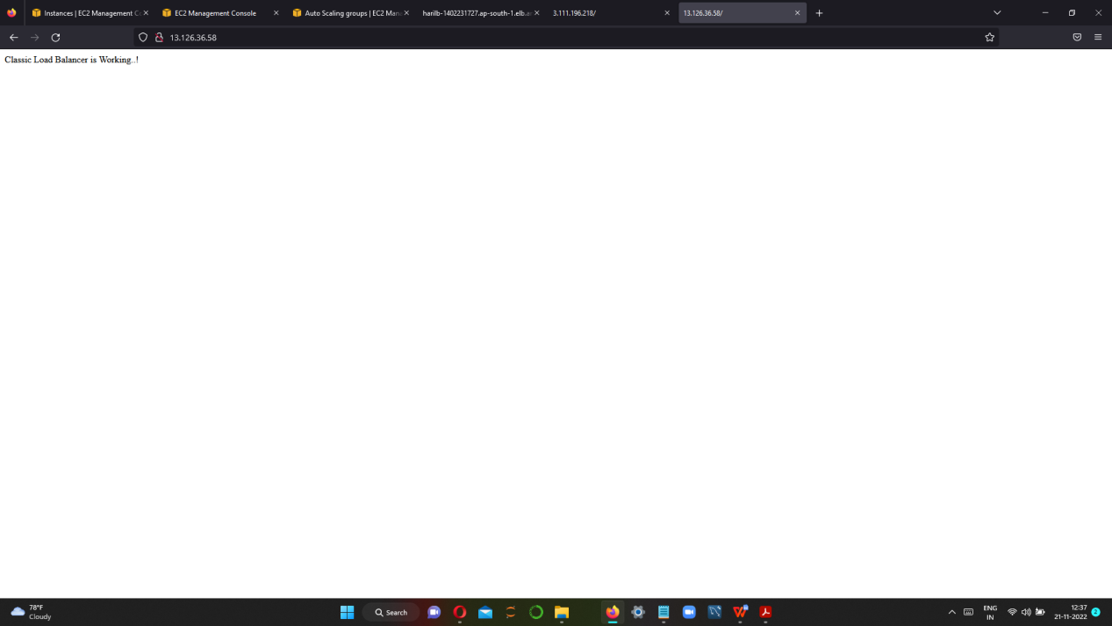

Step-10: Two VMs are created and when they are deleted successfully there will be a new VM will be created because of the minimum capacity we kept.

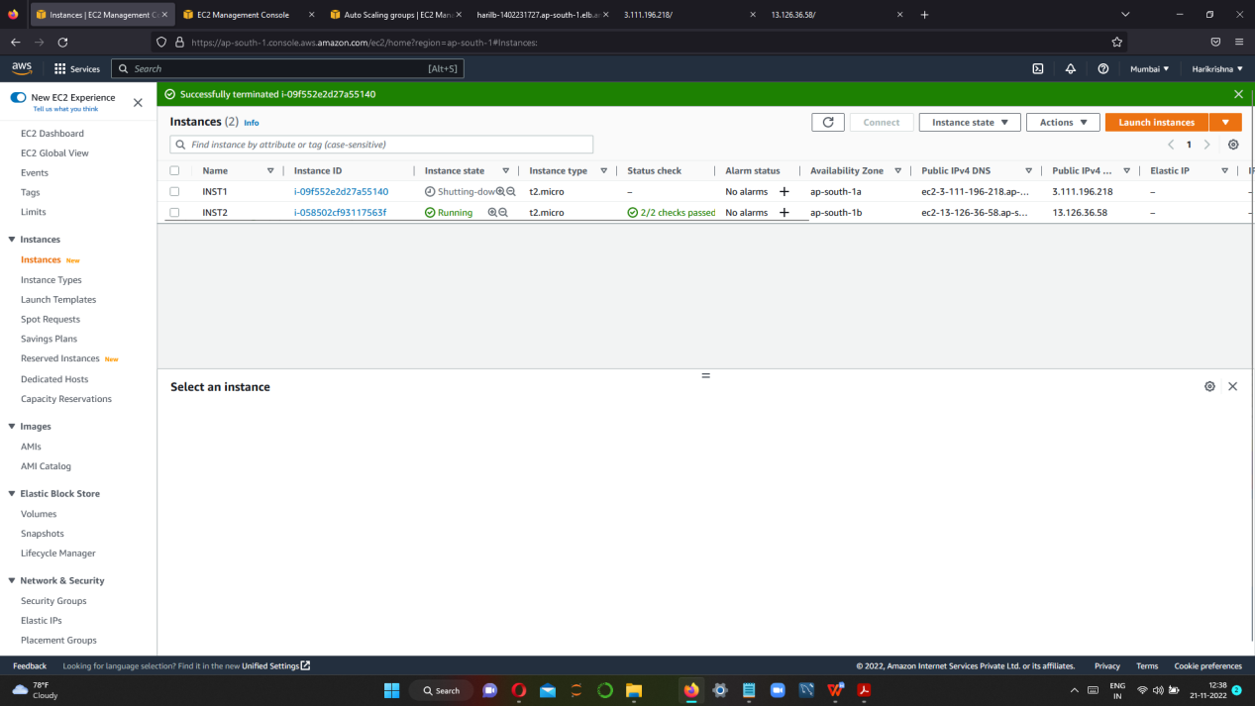

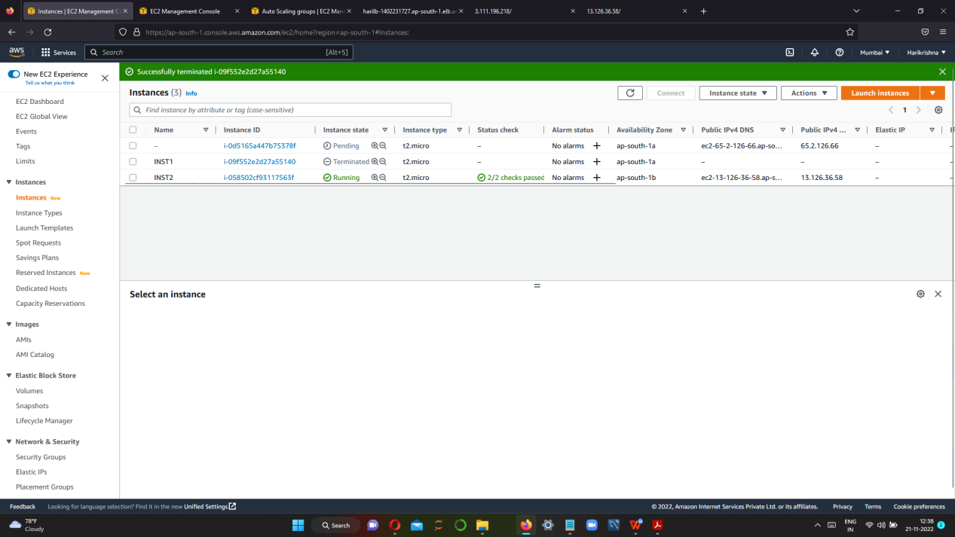

AFTER DELETING THE INSTANCE ANOTHER NEW INSTANCE IS CREATED.